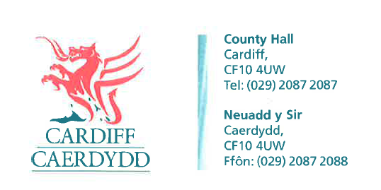
FOI06590
Thank you for your request under the Freedom of Information Act 2000 about Schooner Way Parking Scheme received on 01/04/2015.
We have considered your request and enclose the following information:
- The amount of money that has been collected to date from the parking meters on Schooner Way, Cardiff

Approximately £15,000 between Nov 2014 and end of March 2015.

- Ongoing (proportioned or estimated) costs arising from maintenance/electricity/collection of these machines on Schooner Way, Cardiff

Estimated annual cost £14,000 Nov 2014 and end of March 2015.

- The initial cost of installing the parking machines and parking bay painting on Schooner Way, Cardiff and adjoining roads double yellow line painting.

£99,000 cost to install the scheme.

If you have any queries or concerns, please do not hesitate to contact us.
Please remember to quote the reference number above in any future communications.

