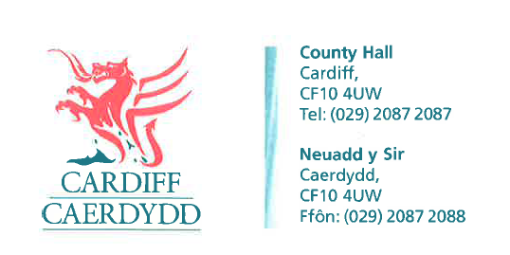
FOI06664
Thank you for your request under the Freedom of Information Act 2000 about Safety Audit Report received on 08/04/2015.
I require the same schematic drawing for the south-bound section of St. Marys Street for its junction with Mill Lane and Custom House Street.
These drawings should also have accompanying road safety audits (Stages 1, 2 & 3), for the bus priority scheme at the junction St. Mary’s Street and Custom House Street, that should indicate the traffic signing and road marking proposals for the road layouts in this area.
If the above information cannot be provided please provide a copy of the Departure from Standards report for all of the above mentioned items and areas in relation to the south-bound section of St. Marys Street for its junction with Mill Lane and Custom House Street.
We have considered your request and enclose the following information:
- There is no drawing for St Marys Street and Customhouse Street as there have been no alterations to the signs or markings.

- The City of Cardiff Council do not hold a road safety audit for the scheme being requested. We can confirm that a road safety audit is not a statutory requirement.

- There are no departures of standards with regards to the lines and signs in this area. They are designed to Traffic Signs Regulations and General Directions 2002.

If you have any queries or concerns, please do not hesitate to contact us.
Please remember to quote the reference number above in any future communications.

